**Statistical Analysis**

The total supply chain cost generated by MOHPSO and five NSDEA variants for seven scenarios are shown in table 1. The last row values shown in bold are the averages of TSCC generated by the algorithms.

|  |  |  |  |  |  |
| --- | --- | --- | --- | --- | --- |
| Table 1. Total Supply Chain Cost generated by the algorithms | | | | | |
| ALGORITHMS | | | | | |
| MOHPSO | DE/RAND/1/BIN | DE/RAND/2/BIN | DE/BEST/1/BIN | DE/BEST/2/BIN | DE-RAND-TO-BEST/1/BIN |
| 142,306 | 109,459 | 109,716 | 111,599 | 110,923 | 111,023 |
| 141,385 | 106,028 | 105,605 | 106,372 | 106,604 | 106,651 |
| 140,629 | 103,424 | 103,403 | 101,585 | 103,194 | 102,042 |
| 119,904 | 100,081 | 99,242 | 98,834 | 100,373 | 100,069 |
| 117,818 | 98,800 | 98,697 | 98,310 | 99,730 | 99,481 |
| 103,290 | 98,393 | 98,320 | 97,973 | 99,358 | 98,784 |
| 100,480 | 98,248 | 98,982 | 97,594 | 99,211 | 98,434 |
| **123,687** | **102,062** | **101,995** | **101,752** | **102,770** | **102,355** |

Statistical analysis is conducted to compare the performance of the five DE variants (DE/RAND/1/BIN, DE/RAND/2/BIN, DE/BEST/1/BIN, DE/BEST/2/BIN and DE/RAND-TO-BEST/1/BIN) and the MOHPSO algorithm. A pairwise comparison should not be straight away used to conduct various comparisons involving a set of algorithms, because the Family-Wise Error Rate (FWER) is not controlled. The procedure followed in this paper is explained in this section.

Friedman’s test is an omnibus test which is used to carry out multiple comparisons among five NSDEA variants and MOHPSO.This test is useful to detect differences among the set of algorithms considered for the analysis. If Friedman’s test rejects the null hypothesis, Wilcoxon-SignedRank testis conducted asa post-hoc testin order to find the concrete pairwise comparisons among the six algorithms.Fifteen p-values for the fifteen pairs of comparisons of the six algorithms are calculated using Wilcoxon-SignedRank test and they are sorted in the ascending order as shown in table 4. Let them be p1, p2, p3,………..and p15. The corrected p-values are calculated as p1/15, p2/14, p3/13…………..and p15/1, respectively, According to the Holm method [1] of multiple comparisons,If the corrected p-values are smaller than the level of significance, alpha=0.01 or 0.05, then we can conclude that there is a significant difference with 1% or 5% significance level respectively.

The Friedman test starts with defining a null and alternate hypothesis. The hypotheses are detailed below.

*Null Hypothesis, Ho: there is no significant difference among the algorithms*

*Alternate Hypothesis, H1: there is a significant difference among the algorithms*

The level of significance (α)is set to 0.05. The degree of freedom is 5 (*k-1,* wherek is the number of algorithms to compare).

The results of Friedman’s test conducted are presented in table 2 and table 3.

Table 2. Mean Ranks for Samples

|  |  |  |  |  |  |
| --- | --- | --- | --- | --- | --- |
| MOHPSO | DE/RAND/1/BIN | DE/RAND/2/BIN | DE/BEST/1/BIN | DE/BEST/2/BIN | DE-RAND-TO-BEST/1/BIN |
| 6 | 2.86 | 2.43 | 1.86 | 4.29 | 3.57 |

Table 3. Test Statistics

|  |  |  |  |
| --- | --- | --- | --- |
| n | χ2 | df | P |
| 7 | 22.27 | 5 | 0 |

The calculated chi-square value is 22.27 with the degree of freedom of 5 and p value is < 0.05, the null hypothesis is rejected. The conclusion is that there is at least one significant difference among the algorithms considered for analysis.

So, the post-hoc test is used to do the pairwise comparisons. The Wilcoxon Signed-rank test is used to generate p-values for the fifteen pairwise comparisons. The p-values obtained in the sorted order and the corrected p-valuesfor them are shown in table 4.

Table 4:Multiple comparisons (Holm's method)

|  |  |  |  |  |  |  |  |
| --- | --- | --- | --- | --- | --- | --- | --- |
| Pairs | PairwiseComparisons in the ascending Order of p Values | | p | corrected p-values | | | Remarks |
| 1 | DE/RAND/1/BIN | MOHPSO | 0.018 | p/15 | = | 0.0012 | p< 0.01 |
| 2 | DE/RAND/2/BIN | MOHPSO | 0.018 | p/14 | = | 0.001285714 |
| 3 | DE/BEST/1/BIN | MOHPSO | 0.018 | p/13 | = | 0.001384615 |
| 4 | DE/BEST/2/BIN | MOHPSO | 0.018 | p/12 | = | 0.0015 |
| 5 | DE-RAND-TO-BEST/1/BIN | MOHPSO | 0.018 | p/11 | = | 0.001636364 |
| 6 | DE/BEST/2/BIN | DE/RAND/1/BIN | 0.028 | p/10 | = | 0.0028 |
| 7 | DE/BEST/2/BIN | DE/RAND/2/BIN | 0.028 | p/9 | = | 0.003111111 |
| 8 | DE/BEST/2/BIN | DE/BEST/1/BIN | 0.043 | p/8 | = | 0.005375 |
| 9 | DE-RAND-TO-BEST/1/BIN | DE/BEST/1/BIN | 0.063 | p/7 | = | 0.009 |
| 10 | DE-RAND-TO-BEST/1/BIN | DE/BEST/2/BIN | 0.063 | p/6 | = | 0.0105 | p< 0.05 |
| 11 | DE-RAND-TO-BEST/1/BIN | DE/RAND/1/BIN | 0.237 | p/5 | = | 0.0474 |
| 12 | DE/BEST/1/BIN | DE/RAND/1/BIN | 0.31 | p/4 | = | 0.0775 |  |
| 13 | DE-RAND-TO-BEST/1/BIN | DE/RAND/2/BIN | 0.398 | p/3 | = | 0.132666667 | p> 0.05 |
| 14 | DE/RAND/2/BIN | DE/RAND/1/BIN | 0.499 | p/2 | = | 0.2495 |  |
| 15 | DE/BEST/1/BIN | DE/RAND/2/BIN | 0.612 | p/1 | = | 0.612 |  |

Among 15 pairwise comparisons shown in table 4, the first 9 pairs and the following 2 pairs are significantly different with p < 0.01 and p < 0.05 respectively. Figure 1 shows the average performance TSCC values for six algorithms shown in table 1. According to the Holm’s method of multiple comparisons as shown in Table 4, it can be concluded that the five NSDEA variants are significantly better than MOHPSO and DE/BEST/1/BIN variant performs better among all algorithms.

Figure 1. Average performances of sixalgorithms.

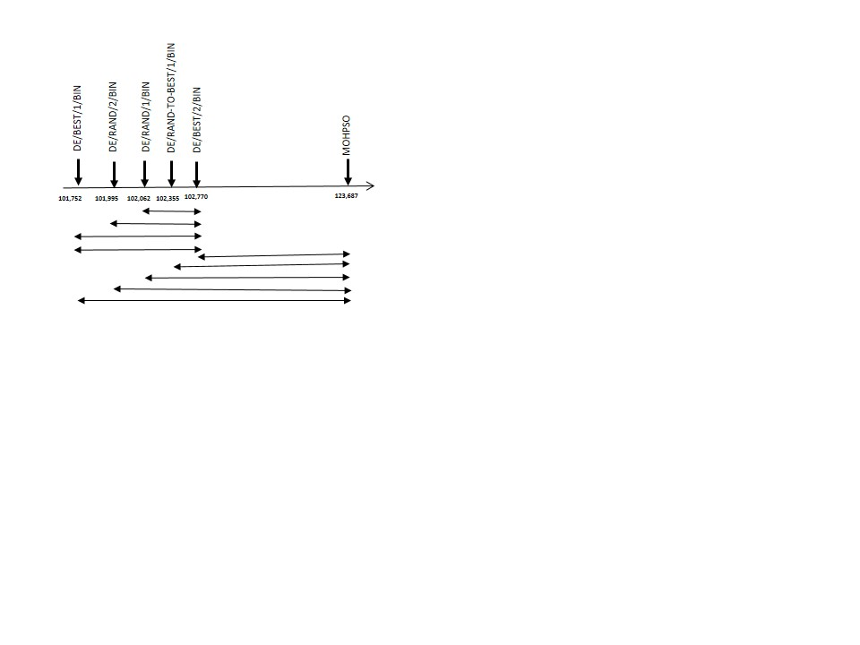

1. Holm, S. (1979). A simple sequentially rejective multiple test procedure.*Scandinavian journal of statistics*, 65-70.